LECTURE-01 (Saturday 20-December-2025)
LECTURE-02 (Saturday 27-December-2025)
- https://agentfactory.panaversity.org/
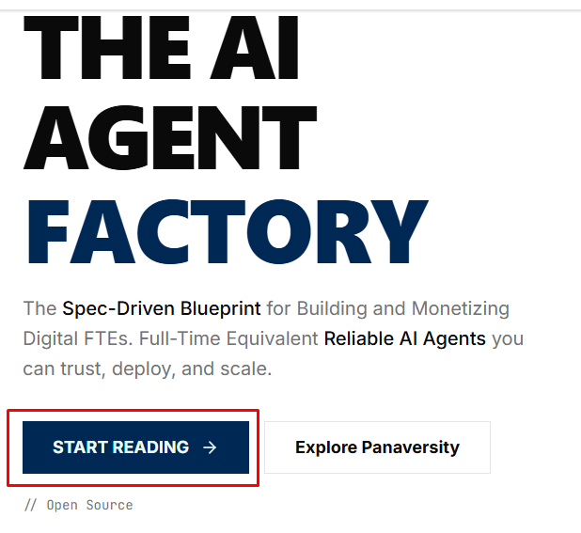
- https://agentfactory.panaversity.org/docs/preface-agent-native
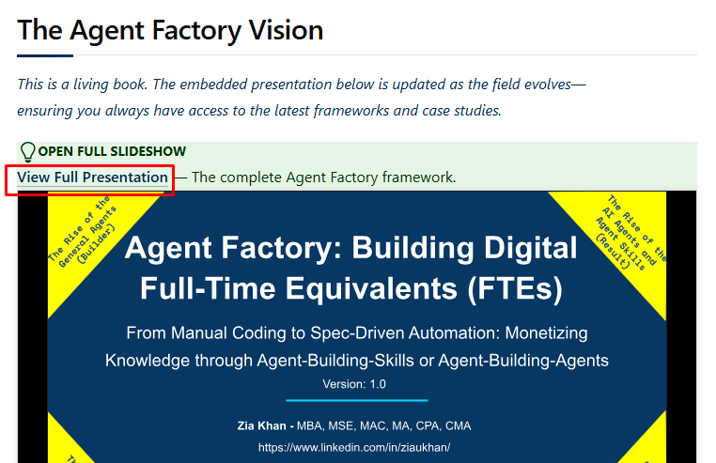
- Presentation: https://docs.google.com/presentation/d/1UGvCUk1-O8m5i-aTWQNxzg8EXoKzPa8fgcwfNh8vRjQ/edit?usp=sharing
- Presentation also downloaded “Agent Factory_ Building Digital Full-Time Equivalents (FTEs).pptx”
- Read all slides
- Slide 1
Agent Factory: It is a design pattern or architectural concept used in AI agent systems (especially LLM-based ones) to create, configure, and manage agents in a consistent, scalable way.
We will use Spec-Driven Development and monetize using knowledge means we will turn our knowledge into usable skills that others pay for.
- Slide 2
Agent Factory Thesis: companies will create and sell digital employees means agents. The created agent will be used for general purpose.
- Slide 3
In 2026, companies will turn new AI protocols (Agents, Agents Skills, MCP, SDKs) into digital employees for profitable business.
MCP (Model Context Protocol) server may be used to get data from SQL database.
- Slide 6
The Agentic AI Playbook: https://youtu.be/Nld8acr-U_4
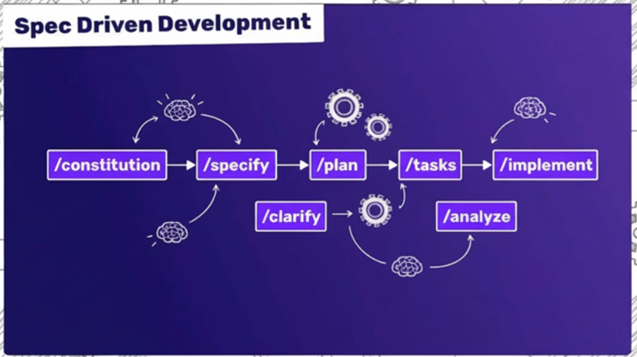
The Agent Factory: https://youtu.be/uWnOfMpfXgI
- Slide 7
Now, we can do programming using English or Urdu (natural language) without using programming languages like Python, Java, TypeScript, C#.
- Slide 8
From User Interface to User Intent means:
- User Interface (Traditional UI approach):
We developer design the interface (forms, buttons, menus) then users interact within those constraints and data collection is structured around what developer expect.
- User Intent approach (Agentic AI):
The AI or system interprets the user’s requirement rather than forcing users into predefined inputs. The users provide information in their own way, using natural language, examples and unstructured inputs. The agent can plan, reason and take actions based on user’s intent/requirement.
- Slide 10
The shifting from “developer-as-typist” to “developer-as-orchestrator” means:
- Developer-as-typist (Traditional approach)
Developers write detailed code line by line, specifying exactly how the system should behave. The developer controls every step, like typing out instructions for the machine to follow.
- Developer-as-orchestrator (Agentic AI approach)
Developers focus on designing goals, constraints and strategies rather than specifying every low-level step. The AI takes on the role of executing, reasoning, and filling in details to achieve the intended outcome.
- Slide 11
“Future of Work: A Partnership” framework describes how humans, AI agents and robots collaborate to achieve outcomes more efficiently and intelligently.
- People/Humans (Orchestrator) will create by providing intent, judgment and supervision.
- Agents execute digital tasks and coordinate workflows.
- Robots execute physical tasks efficiently.
- Slide 12
We are making AI our partner.
- Slide 13
- Predictive AI: Deep/Machine learning
- Generative AI : creating content
- Agentic AI: autonomous, memorize
- Slide 14
Goal: We will assign goal to AI Agent.
State and Memory: AI Agent will maintain State and Memory (Conversation History). “Stateless” and “Stateful” describe how the AI system manages context and memory across interactions.
- Stateless Agentic AI: does not remember past interactions or context between prompts. Each prompt is treated independently. The agent has no memory of what happened before.
Pros: Simpler, faster, easier to scale.
Cons: Cannot build long-term understanding, cannot adapt to ongoing goals.
Example: A stateless AI answering a single question like:
User: “Who is the CEO of Microsoft?”
The AI answers, but for the next question, it forgets the previous interaction.
- Stateful Agentic AI: remembers past interactions or context, maintaining a state that can inform future decisions. It enables multi-step reasoning, long-term planning and personalized interactions.
Pros: Can track ongoing tasks, adapt to user intent, and coordinate complex workflows.
Cons: Requires more memory, careful management, and sometimes privacy/security considerations.
Example: A Stateful AI helping a user plan a project:
User: “Book a flight to Paris.”
Later: “Also, reserve a hotel near the Eiffel Tower.”
The AI remembers the flight context and can coordinate the hotel booking appropriately.
In Agentic AI terms:
Stateless = “reactive” means responds only to what you tell it right now.
Stateful = “agentic” means remembers your goals and can act autonomously over time to achieve them.
Autonomy: It is the AI’s capacity to make decisions, plan actions and execute tasks on its own, based on user intent or objectives. Autonomy adjusts without micromanagings means AI’s ability to adapt its actions on its own when conditions change, without needing constant human intervention.
- Slide 15
LLM (Large Language Model) to LAM (Large Action Model)
- LLM (Large Language Model) - “Knows & Says”
LLM takes text in, produces text out and optimizes for next-token prediction. It means:
- “LLM takes text in”: An LLM’s input is just a sequence of tokens where a token is usually a word (agent), part of a word (autono + my), punctuation and special markers (system, user and tool).
Example: Explain autonomy in agentic AI
The LLM does not see meaning. LLM sees something like:
[Explain] [aut] [onomy] [in] [agent] [ic] [AI]
That sequence is converted into numbers (embedding). At this stage, there is no understanding, only encoded text.
- “Produces text out”: The model’s only possible output is the next token which is not an idea, not an answer and not a plan. LLM Just generate output “What token is most likely to come next?” like:
Input tokens →
Predict token #1 →
Predict token #2 →
Predict token #3 →
...
Example:
"The future of work is"
→ "a"
→ "collaboration"
→ "between"
→ "humans"
→ "and"
→ "AI"

LLM at each step:
- looks at all previous tokens
- chooses one next token
- appends it
- repeats

- “Optimizes for next-token prediction”: During training, the LLM is shown billions of text examples.
Example: "The capital of France is ____"
The correct next token is "Paris"
The LLM:
- predicts a probability for every possible token.
- is rewarded when Paris gets high probability
- is penalized when it doesn’t
Over time, LLM learns:
- Grammar
- Facts
- Reasoning patterns
- Style
- Structure
Important: The model is not trained to be correct. It is trained to be probabilistically likely.
Human knowledge is embedded in language, next-token prediction accidentally learns:
- Logical reasoning
- Step-by-step explanations
- Cause and effect
- Planning-like patterns
An agent recover from failure, the model has seen millions of:
- Explanations
- Postmortems
- design docs
- discussions
It predicts what usually comes next in such contexts.
Reasoning emerges as a side effect, not a goal.
LLM is not:
- Executing code
- Tracking real-world state
- Checking truth
- Knowing outcomes
- Monitoring success
- Acting in an environment
LLM does not know if what it said:
- Worked
- Failed
- Was executed
- Changed anything
Once output is produced, LLM is done but what output is produced, matters in Agentic AI. This is the exact boundary between LLM and Agent/LAM.
Example:
LLM:
Input: "Deploy the service"
Output: "Here are the steps to deploy..."

Agent / LAM:
Input: Goal = Deploy service
LLM: Generates plan
Agent: Executes steps
Agent: Observes results
Agent: Adjusts plan

Therefore, LLMs describe actions while Agents perform actions.
Consider, LLM as an extremely powerful autocomplete engine trained on the internet but not a thinker, a decision-maker and an actor yet.
One-line summary: LLMs don’t know answers. LLM predicts what text should come next given context.
This summary explains:
- Hallucinations
- why tools are needed
- why memory matters
- why autonomy requires agents
- why LAMs exist
In an agent system, LLM is usually responsible for:
- Reasoning (“What should be done?”)
- Planning (“What steps make sense?”)
- Interpreting context (user intent, environment state)
- Generating instructions (plans, tool calls, prompts)
In agentic systems, LLM does not:
- execute real-world actions
- maintain persistent goals by itself
- close feedback loops autonomously
- own state across time (unless wrapped)
In short, LLM = Brain without hands
LLMs are not enough for Agents because early “agents” were:
Prompt → LLM → Text → Human executes
Problems:
- Humans had to translate text into action
- No continuous autonomy
- No environment feedback
- No goal persistence
- No error recovery
Due to which LAM emerges.
LAM (Large Action Model): “Decides & Does”
A LAM is not just a bigger LLM. A LAM is a model (or system) optimized to select, sequence and execute actions in an environment to achieve a goal.
Key differences:
LLM LAM
- Output:
LLM – Text
LAM – Actions
- Primary Skill
LLM - Language reasoning
LAM - Decision + execution
- Environment
LLM – Passive
LAM – Interactive
- Feedback
LLM - None or human
LAM - Continuous
- Time
LLM - Single turn
LAM - Multi-step, long-running
- Autonomy
LLM – Low
LAM – High

LAM = Brain + Hands + Feedback Loop
LAM in an Agentic Architecture: A LAM is usually an orchestration layer, not a single neural net.
In Agentic AI, an orchestration layer is a controller that:
- Decides what to do next
- Chooses which tool, model, or API to call
- Manages multi-step workflows
- Maintains state, memory, and goals
- Handles planning, execution, and retries
LAM’s typical loop:
Goal →
Perceive State →
Decide Action →
Execute Tool/API →
Observe Result →
Adjust Plan →
Repeat

Components inside a LAM system:
LLM → reasoning & planning
Policy layer → action selection rules
Tool executor → APIs, code, robots, browsers
Memory → state, history, outcomes
Evaluator → success/failure assessment

So, LAM = LLM + Tools + Memory + Control Logic
Stateless vs Stateful (LLM → LAM shift)
LLM is typically stateless:
- Each call is isolated
- Memory is injected manually via prompt
LAM is stateful by design as LAM tracks:
- Goal progress
- Past actions
- Environment changes
- Learns from outcomes
This statefulness is what enables:
- Autonomy
- Adaptation
- Long-running agents
Autonomy: The Core LLM → LAM Transition
LLM autonomy:
- “Tell me what to do next”
- Needs constant prompting
- Human-in-the-loop by default
LAM autonomy:
- “Here is the goal. Handle it.”
- Self-directing
- Self-correcting
- Human-on-the-loop (oversight)

“Adjusts without you micromanaging” means LAM:
- Observes failure
- Re plans automatically
- Chooses alternative actions
- Continues until goal or stop condition
Real-World Examples
Example 1:
LLM:
“Here is a SQL query you can run.”
LAM:
- Connects to DB
- Runs the query
- Detects error
- Fixes schema mismatch
- Reruns
- Returns result
Example 2:
LLM:
“Steps to deploy an app.”
LAM:
- Provisions infra
- Deploys service
- Monitors health
- Rolls back on failure

One-Line Summary:
LLMs generate intelligence.
LAMs operationalize intelligence.
OR
LLM → “What should happen?”
LAM → “Make it happen.”
- Slide 16
Agents can see, hear, reason, act (tool calling) and remember.
AI will have impact at every department.
- Slide 17
How we work: We should provide complete information to Agents as Agent will be our partner.
How we transact: autonomous systems do complex transactions.
How we build: no traditional coding, AI will generate application
- Slide 18
In 2025 Feb, Agentic AI started
Then, MCP started
Then, Claude Code CLI started
Then, Open AI agents SDK
- Slide 19
Core Strategic Decision: we have two agents
- Custom or Expert agent: this agent is created via OpenAI Agent SDK to perform specific task repeatedly.
- General agent (Smart Consultant): generic-purpose AI agents like Claude Code
- Slide 23
Claude code is not only for coding but it is a general agent.
Claude code is an autonomous problem solver.
Coding agents like Cursor is specific for software development
Claude code is a general agent.
A general agent is a digital employee.
- Slide 26
Code is universal interface means everywhere code is used.

LECTURE-03 (Saturday 03-January-2026)
- Presentation: https://docs.google.com/presentation/d/1UGvCUk1-O8m5i-aTWQNxzg8EXoKzPa8fgcwfNh8vRjQ/edit?usp=sharing
- Skills path can be as : .claude/skills/fastapi/SKILL.md
- Skill reduces 80% token usage
- Custom Agent have defined boundaries and agent perform actions which includes memory
- Skill is a pattern of performing a task.
- For repeated task, provide knowledge/pattern of performing task (skill) to agent.
- Skill.md file pattern: skill name (header) and description
- There are different types of Skills:
- Global level
- Project level
- Plugin level
- Skills are very important for Latency (response time)
- We can create Plugins: https://code.claude.com/docs/en/plugins#create-plugins
- Obsedient Vault: every company have its own obsedient valult. Obsedient vault will have information/skills of all projects.
- General agent can be used control Linkedin account.
- Even ,agent can deploy applications to server.
- There are two types of OpenAI applications:
- Deterministic backend means Zero Backend LLM and all cost will occur at LLM like ChatGPT
- Hybrid architecture

LECTURE-04 (Saturday 10-January-2026)
- Presentation: https://docs.google.com/presentation/d/1UGvCUk1-O8m5i-aTWQNxzg8EXoKzPa8fgcwfNh8vRjQ/edit?usp=sharing
- Side 41
- Skill file contains like “yaml” file data which indicates skill name (used for skill selection)
- Skill can use script (.py) as tool but when needed
- Skill file format:
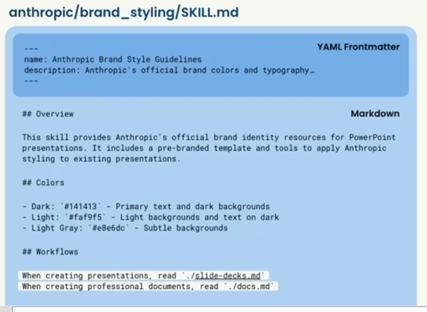
- yaml section : contains name and description
- Markdown section : contains instructions
When we provide skill file to claude code then claude code will load markdown data then use reference files mentioned in markdown data.
- Slide 44
Agent present in center is “Claude” agent.
The complete picture shows “Agent Loop”.
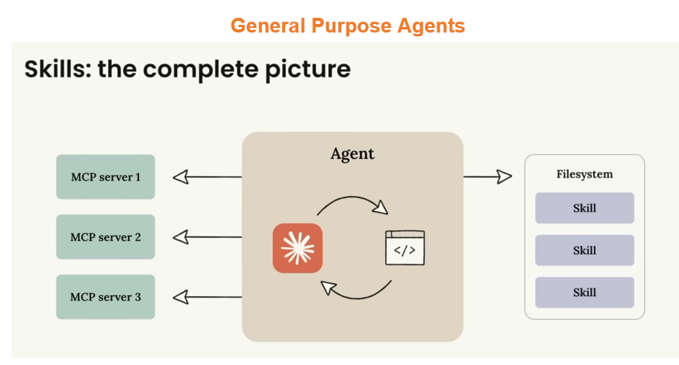
- FTE stands for “Full Time Equivalent”, means “24x7 Digital Employee”
- Passive AI Agent: It is an AI system that does not act on its own. It waits for explicit human input, then responds means no initiative, no autonomous decisions and no background actions. It is “react-only” agent.
- Persistence: when we work on anything then we should remember old work
- Claude CLI command which keeps persistence :
\init
OR
claude init
- We want to enhance knowledge of digital employee, use command:
Write python hello world in app1.py
Then use command:
/memory
- Playwright is the “hands and eyes” of an AI agent on the web. Playwright lets AI agents interact with websites the same way humans do like:
- open pages
- click buttons
- fill forms
- read text
- download files
- take screenshots
As LLMs can’t:
- click links
- log into dashboards
- scrape JS-heavy sites
- submit forms
- There are many events of Playwright. Main event categories (core ones):
- Browser events (emitted by browser)
- Disconnected
- BrowserContext events (emitted by context)
- Page
- Close
- Request
- Response
- Requestfailed
- requestfinished
- Page events (emitted by page)
- Load
- Domcontentloaded
- Close
- Crash
- popup
- frameattached
- framedetached
- framenavigated
- request
- response
- requestfailed
- requestfinished
- console
- dialog
- download
- filechooser
- websocket
- worker
- pageerror
- Request / Response events (used heavily in AI agents & scraping)
- Request
- Response
- Websocket (framereceived, framesent, close, socketerror)
- Worker events (emitted by worker)
- close
- Download events (emitted by download)
- path (promise-based, not listener-style)
- Giving auto approval to Claude Code (agent) is dangerous but it is possible by command:
claude --dangerously-skip-permissions
- Command to get MCP tools:
/mcp
- Whenever we connect MCP server then MCP’s tokens will go in each prompt request.
- By MCP, we can connect any external application to Claude Code
- When we create Skills then in communication with LLM, only Skill’s name and description will go in each request due to which 80% to 90% tokens will be reduced.
- Advantage of sub-agent:
If we try to do everything with a single agent then context window fills up which results older conversation messages are lost or truncated. This is bad if we need AI to remember the full history of communication for continuity.
This issue can be overcome by using sub-agents because each sub-agent works in a smaller scope, so the context window doesn’t overflow. In this way, we can maintain multiple conversations in parallel without losing important information.
- https://github.com/anthropics/claude-code/tree/main/plugins: It is part of Claude Code’s plugin system which contains built‑in extensions that add extra tools, commands and workflows to Claude Code.
- /hooks (event driven): Whenever any event occurred, we can run any command against hook. In case of any hook event occurred, tool will be called and data will be retrieved, called session.
- Hook: If any event occurred then agent will automatically perform action which we have mentioned
- FTE:
- General Agent: Claude
- Connect CLI
- Connect MCP
- Connect Skills
- Connect Sub-Agent (Expert Agent)
- Connect Hook (event driven action performed)
- Skill Marketplace: It is essentially a hub or store for AI “skills” which provides prebuilt tools, automations or capabilities that we can add to an AI assistant like Claude Code (or similar platforms) to make it do more specialized tasks. Think of it like an app store, but for AI abilities.

LECTURE-05 (Saturday 17-January-2026)
- Presentation: https://docs.google.com/presentation/d/1UGvCUk1-O8m5i-aTWQNxzg8EXoKzPa8fgcwfNh8vRjQ/edit?usp=sharing
- Side 49
- Skillport: It is like application store. It contains all skills, we just download skill and use skill.
- All LLMs are stateless
- Slide 53
- Scaling means extending to multiple. One user to 5 user, if more users then trust matters as someone can misuse.
- Slide 65
- Whitelabel: Any company will buy agent from us and use or show your agent as their own.
- Enterprise site license: Company will use your agent without any limitation in whole company.
- Developer license: any other company will use your agent in their agent.

LECTURE-06 (Saturday 24-January-2026)
- Test

